**Omar Ali Al-Naimi**

**Lehman College, Biology Department**

**Dr. Maryam Bamshad Laboratory**

**Correlation and Regression Analyses**

1. Terminology and data orientation:
2. All control: means that the compared groups consist of variables those are never been stressed (+male+cover and paired housing).
3. All graphs below are for analyzing correlation and regression of male vs female.
4. The top 7 graphs are for behavior parameters, and the last 4 graphs are for Excretion parameters (Feces & Urine combined).
5. The correlation and regression (All graphs) are between Day1 vs Day2, and Day1 vs Day3.
6. Each graph consists of 2 sections, the top one is Day1 vs Day2, and the bottom one is Day1 vs Day3
7. In all graphs, Day1 is always on X-axis, and Day2 & Day3 are on y-axis.
8. Excretion graphs represent more diverse analyses. Please see its special Terminology and data orientation below.
9. Each graph is followed by Trend Lines Model for detailed statistical information.
10. Result and Interpretation:
11. In comparison with Male, Female gender, consistently, showed positive correlation, small p-value for Pearson correlation, and good R-Squared. The detailed information is available for each graph in its own Trend Lines Model.
12. The pattern of stress level: the reiteration of stress experience throughout the three days of the experiment has increased the stress level in female but not in Male. In other words, Male gender is more adaptable to stress re-experience than Female.
13. The next analyses will be between the stressed groups (all combined) vs non-stressed group.

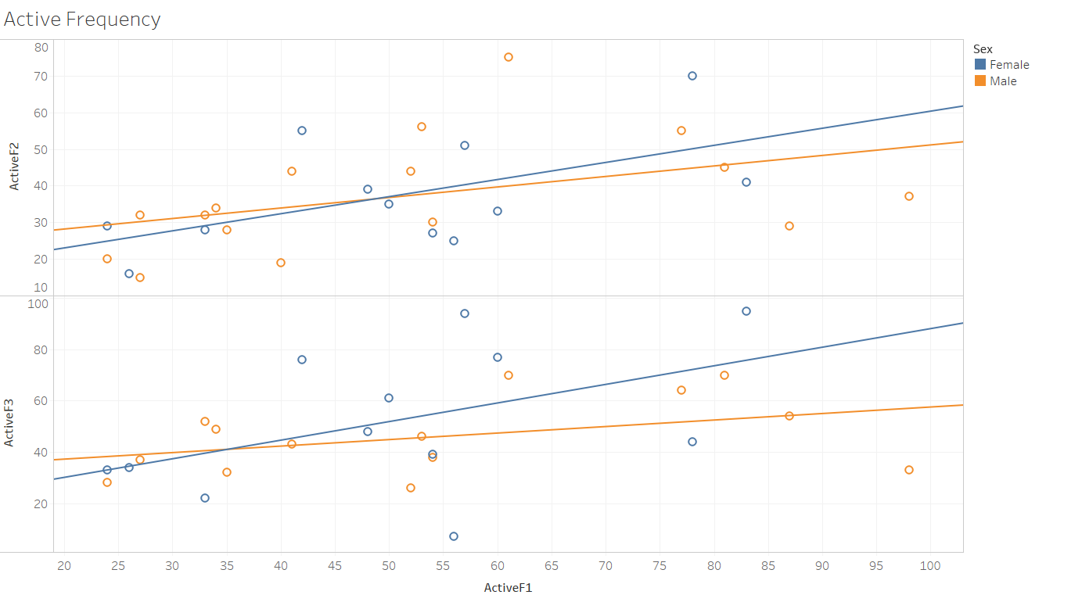

Figure 1: All control, male vs female (Active Frequency parameter)

**Trend Lines Model**

A linear trend model is computed for ActiveF2 given ActiveF1.

|  |  |
| --- | --- |
| **Model formula:** | Sex*( ActiveF1 + intercept ) |
| **Number of modeled observations:** | 28 |
| **Number of filtered observations:** | 0 |
| **Model degrees of freedom:** | 4 |
| **Residual degrees of freedom (DF):** | 24 |
| **SSE (sum squared error):** | 4644.81 |
| **MSE (mean squared error):** | 193.534 |
| **R-Squared:** | 0.24076 |
| **Standard error:** | 13.9116 |
| **p-value (significance):** | 0.0805662 |

**Analysis of Variance:**

|  |  |  |  |  |  |
| --- | --- | --- | --- | --- | --- |
| **Field** | **DF** | **SSE** | **MSE** | **F** | **p-value** |
| **Sex** | 2 | 83.125126 | 41.5626 | 0.214756 | 0.808272 |

A linear trend model is computed for ActiveF3 given ActiveF1.

|  |  |
| --- | --- |
| **Model formula:** | Sex*( ActiveF1 + intercept ) |
| **Number of modeled observations:** | 26 |
| **Number of filtered observations:** | 1 |
| **Model degrees of freedom:** | 4 |
| **Residual degrees of freedom (DF):** | 22 |
| **SSE (sum squared error):** | 9173.58 |
| **MSE (mean squared error):** | 416.981 |
| **R-Squared:** | 0.226762 |
| **Standard error:** | 20.4201 |
| **p-value (significance):** | 0.122757 |

**Analysis of Variance:**

|  |  |  |  |  |  |
| --- | --- | --- | --- | --- | --- |
| **Field** | **DF** | **SSE** | **MSE** | **F** | **p-value** |
| **Sex** | 2 | 948.21897 | 474.109 | 1.13701 | 0.338916 |

**Individual trend lines:**

|  |  |  |  |  |  |  |  |  |  |
| --- | --- | --- | --- | --- | --- | --- | --- | --- | --- |
| **Panes** | | **Color** | **Line** | | **Coefficients** | | | | |
| **Row** | **Column** | **Sex** | **p-value** | **DF** | **Term** | **Value** | **StdErr** | **t-value** | **p-value** |
| ActiveF2 | ActiveF1 | Male | 0.0966545 | 14 | ActiveF1 | 0.287001 | 0.161168 | 1.78075 | 0.0966545 |
|  | | | | | intercept | 22.407 | 9.0633 | 2.47227 | 0.0268664 |
| ActiveF2 | ActiveF1 | Female | 0.0538186 | 10 | ActiveF1 | 0.466773 | 0.213658 | 2.18467 | 0.0538186 |
|  | | | | | intercept | 13.6502 | 11.503 | 1.18666 | 0.262788 |
| ActiveF3 | ActiveF1 | Male | 0.146191 | 12 | ActiveF1 | 0.254077 | 0.163517 | 1.55383 | 0.146191 |
|  | | | | | intercept | 32.1189 | 9.60136 | 3.34524 | 0.0058313 |
| ActiveF3 | ActiveF1 | Female | 0.123295 | 10 | ActiveF1 | 0.725173 | 0.430894 | 1.68295 | 0.123295 |
|  | | | | | intercept | 15.5766 | 23.1987 | 0.671443 | 0.517148 |
| ---------------------------------------------------------- | | | | |  |  |  |  |  |

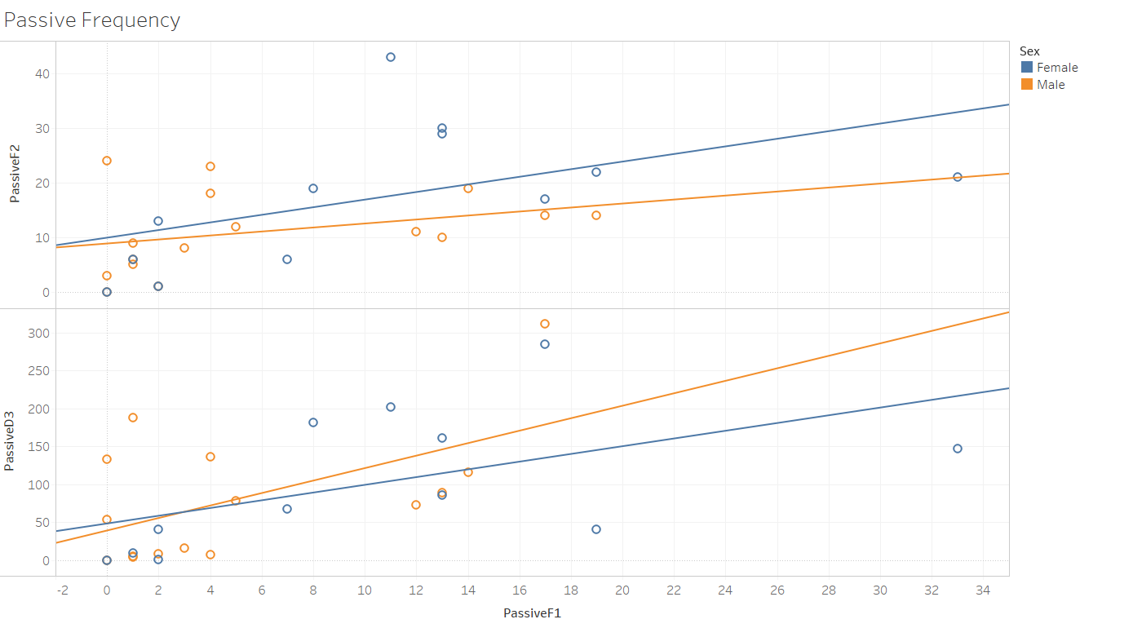

Figure 2: All control, male vs female (Passive Frequency parameter)

**Trend Lines Model**

A linear trend model is computed for PassiveD3 given PassiveF1. The model may be significant at p <= 0.05.

|  |  |
| --- | --- |
| **Model formula:** | Sex*( PassiveF1 + intercept ) |
| **Number of modeled observations:** | 27 |
| **Number of filtered observations:** | 1 |
| **Model degrees of freedom:** | 4 |
| **Residual degrees of freedom (DF):** | 23 |
| **SSE (sum squared error):** | 141010 |
| **MSE (mean squared error):** | 6130.86 |
| **R-Squared:** | 0.301787 |
| **Standard error:** | 78.2998 |
| **p-value (significance):** | 0.0378547 |

**Analysis of Variance:**

|  |  |  |  |  |  |
| --- | --- | --- | --- | --- | --- |
| **Field** | **DF** | **SSE** | **MSE** | **F** | **p-value** |
| **Sex** | 2 | 4042.6964 | 2021.35 | 0.3297 | 0.722482 |

A linear trend model is computed for PassiveF2 given PassiveF1. The model may be significant at p <= 0.05.

|  |  |
| --- | --- |
| **Model formula:** | Sex*( PassiveF1 + intercept ) |
| **Number of modeled observations:** | 28 |
| **Number of filtered observations:** | 0 |
| **Model degrees of freedom:** | 4 |
| **Residual degrees of freedom (DF):** | 24 |
| **SSE (sum squared error):** | 2069.6 |
| **MSE (mean squared error):** | 86.2334 |
| **R-Squared:** | 0.287257 |
| **Standard error:** | 9.28619 |
| **p-value (significance):** | 0.0404033 |

**Analysis of Variance:**

|  |  |  |  |  |  |
| --- | --- | --- | --- | --- | --- |
| **Field** | **DF** | **SSE** | **MSE** | **F** | **p-value** |
| **Sex** | 2 | 127.25475 | 63.6274 | 0.737851 | 0.488676 |

**Individual trend lines:**

|  |  |  |  |  |  |  |  |  |  |
| --- | --- | --- | --- | --- | --- | --- | --- | --- | --- |
| **Panes** | | **Color** | **Line** | | **Coefficients** | | | | |
| **Row** | **Column** | **Sex** | **p-value** | **DF** | **Term** | **Value** | **StdErr** | **t-value** | **p-value** |
| PassiveF2 | PassiveF1 | Male | 0.21153 | 14 | PassiveF1 | 0.365854 | 0.279437 | 1.30925 | 0.21153 |
|  | | | | | intercept | 8.86738 | 2.45205 | 3.61631 | 0.0028062 |
| PassiveF2 | PassiveF1 | Female | 0.0878732 | 10 | PassiveF1 | 0.69659 | 0.368312 | 1.8913 | 0.0878732 |
|  | | | | | intercept | 9.93581 | 5.12117 | 1.94014 | 0.0810617 |
| PassiveD3 | PassiveF1 | Male | 0.0327707 | 13 | PassiveF1 | 8.22996 | 3.44538 | 2.3887 | 0.0327707 |
|  | | | | | intercept | 38.8195 | 26.2543 | 1.4786 | 0.163065 |
| PassiveD3 | PassiveF1 | Female | 0.078717 | 10 | PassiveF1 | 5.09789 | 2.60383 | 1.95785 | 0.078717 |
|  | | | | | intercept | 48.0888 | 36.2047 | 1.32825 | 0.213613 |
| ------------------------------------------------------------- | | | | |  |  |  |  |  |

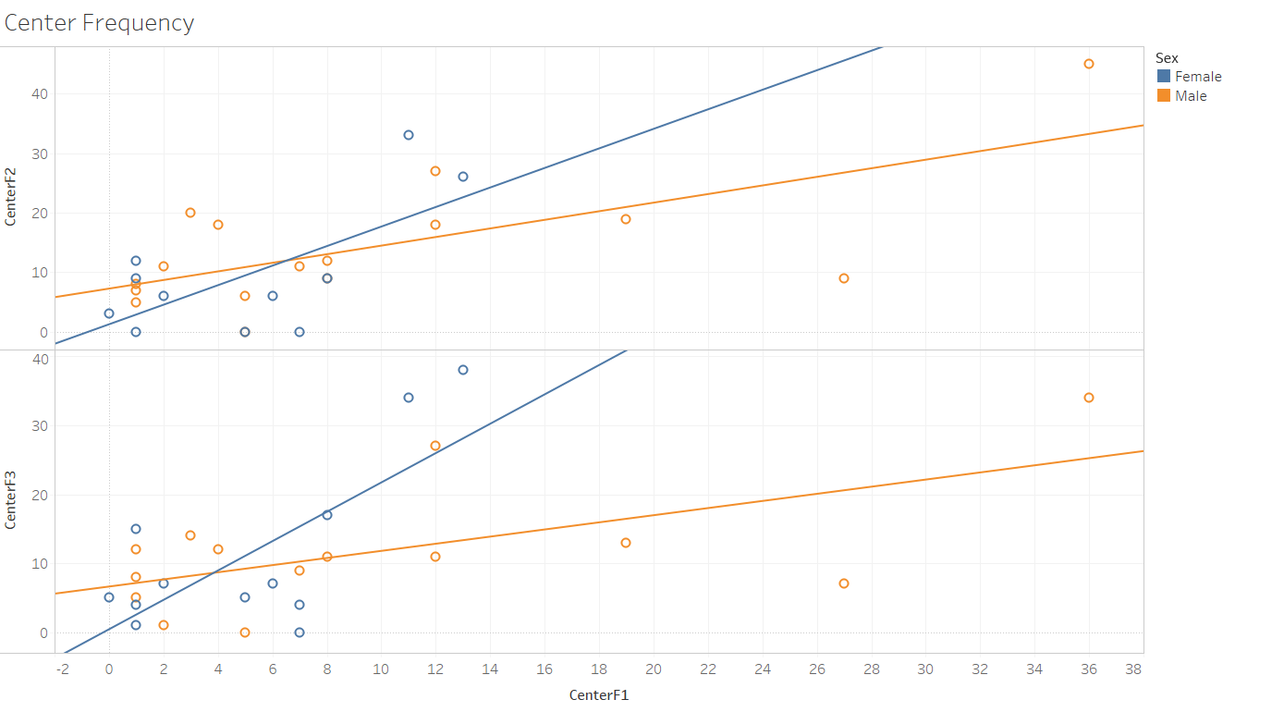

Figure 3:All control, male vs female (Center Frequency parameter)

**Trend Lines Model**

A linear trend model is computed for CenterF2 given CenterF1. The model may be significant at p <= 0.05.

|  |  |
| --- | --- |
| **Model formula:** | Sex*( CenterF1 + intercept ) |
| **Number of modeled observations:** | 27 |
| **Number of filtered observations:** | 0 |
| **Model degrees of freedom:** | 4 |
| **Residual degrees of freedom (DF):** | 23 |
| **SSE (sum squared error):** | 1573.4 |
| **MSE (mean squared error):** | 68.4087 |
| **R-Squared:** | 0.480396 |
| **Standard error:** | 8.27095 |
| **p-value (significance):** | 0.0015323 |

**Analysis of Variance:**

|  |  |  |  |  |  |
| --- | --- | --- | --- | --- | --- |
| **Field** | **DF** | **SSE** | **MSE** | **F** | **p-value** |
| **Sex** | 2 | 152.1736 | 76.0868 | 1.11224 | 0.345872 |

A linear trend model is computed for CenterF3 given CenterF1. The model may be significant at p <= 0.05. The factor Sex may be significant at p <= 0.05.

|  |  |
| --- | --- |
| **Model formula:** | Sex*( CenterF1 + intercept ) |
| **Number of modeled observations:** | 26 |
| **Number of filtered observations:** | 1 |
| **Model degrees of freedom:** | 4 |
| **Residual degrees of freedom (DF):** | 22 |
| **SSE (sum squared error):** | 1507.49 |
| **MSE (mean squared error):** | 68.5223 |
| **R-Squared:** | 0.463593 |
| **Standard error:** | 8.27782 |
| **p-value (significance):** | 0.0029153 |

**Analysis of Variance:**

|  |  |  |  |  |  |
| --- | --- | --- | --- | --- | --- |
| **Field** | **DF** | **SSE** | **MSE** | **F** | **p-value** |
| **Sex** | 2 | 511.92193 | 255.961 | 3.73544 | 0.0401167 |

**Individual trend lines:**

|  |  |  |  |  |  |  |  |  |  |
| --- | --- | --- | --- | --- | --- | --- | --- | --- | --- |
| **Panes** | | **Color** | **Line** | | **Coefficients** | | | | |
| **Row** | **Column** | **Sex** | **p-value** | **DF** | **Term** | **Value** | **StdErr** | **t-value** | **p-value** |
| CenterF2 | CenterF1 | Male | 0.0040165 | 14 | CenterF1 | 0.722551 | 0.210301 | 3.43579 | 0.0040165 |
|  | | | | | intercept | 7.24342 | 2.84733 | 2.54394 | 0.0233908 |
| CenterF2 | CenterF1 | Female | 0.0232989 | 9 | CenterF1 | 1.64286 | 0.60221 | 2.72805 | 0.0232989 |
|  | | | | | intercept | 1.24026 | 3.9406 | 0.314739 | 0.760134 |
| CenterF3 | CenterF1 | Male | 0.0214568 | 12 | CenterF1 | 0.517235 | 0.195704 | 2.64294 | 0.0214568 |
|  | | | | | intercept | 6.61583 | 2.78933 | 2.37183 | 0.0352837 |
| CenterF3 | CenterF1 | Female | 0.007859 | 10 | CenterF1 | 2.12938 | 0.643021 | 3.31153 | 0.007859 |
|  | | | | | intercept | 0.414858 | 4.23288 | 0.0980084 | 0.923862 |

------------------------------------------------------------------------------------------------------------------------------------------

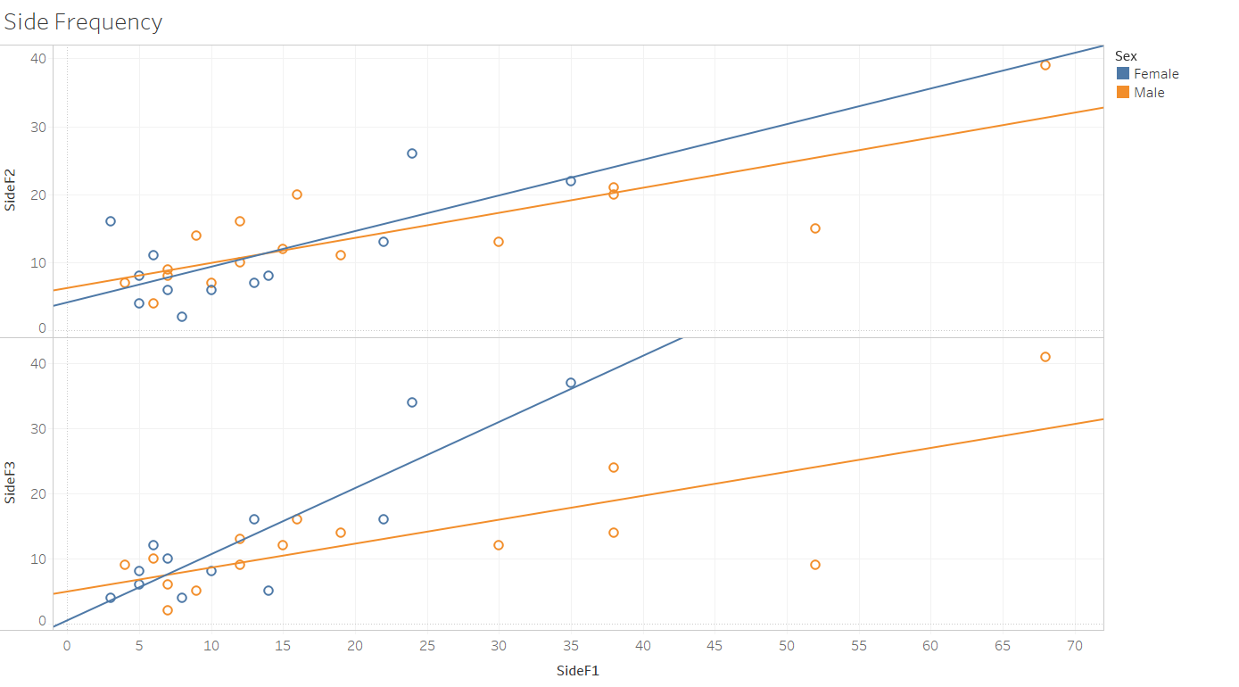

Figure 4: All control, male vs female (Side Frequency parameter)

**Trend Lines Model**

A linear trend model is computed for SideF2 given SideF1. The model may be significant at p <= 0.05.

|  |  |
| --- | --- |
| **Model formula:** | Sex*( SideF1 + intercept ) |
| **Number of modeled observations:** | 28 |
| **Number of filtered observations:** | 0 |
| **Model degrees of freedom:** | 4 |
| **Residual degrees of freedom (DF):** | 24 |
| **SSE (sum squared error):** | 636.604 |
| **MSE (mean squared error):** | 26.5252 |
| **R-Squared:** | 0.626868 |
| **Standard error:** | 5.15026 |
| **p-value (significance):** | < 0.0001 |

**Analysis of Variance:**

|  |  |  |  |  |  |
| --- | --- | --- | --- | --- | --- |
| **Field** | **DF** | **SSE** | **MSE** | **F** | **p-value** |
| **Sex** | 2 | 20.955476 | 10.4777 | 0.395011 | 0.677972 |

A linear trend model is computed for SideF3 given SideF1. The model may be significant at p <= 0.05. The factor Sex may be significant at p <= 0.05.

|  |  |
| --- | --- |
| **Model formula:** | Sex*( SideF1 + intercept ) |
| **Number of modeled observations:** | 27 |
| **Number of filtered observations:** | 1 |
| **Model degrees of freedom:** | 4 |
| **Residual degrees of freedom (DF):** | 23 |
| **SSE (sum squared error):** | 820.203 |
| **MSE (mean squared error):** | 35.661 |
| **R-Squared:** | 0.681855 |
| **Standard error:** | 5.97168 |
| **p-value (significance):** | < 0.0001 |

**Analysis of Variance:**

|  |  |  |  |  |  |
| --- | --- | --- | --- | --- | --- |
| **Field** | **DF** | **SSE** | **MSE** | **F** | **p-value** |
| **Sex** | 2 | 502.45756 | 251.229 | 7.04492 | 0.0041062 |

**Individual trend lines:**

|  |  |  |  |  |  |  |  |  |  |
| --- | --- | --- | --- | --- | --- | --- | --- | --- | --- |
| **Panes** | | **Color** | **Line** | | **Coefficients** | | | | |
| **Row** | **Column** | **Sex** | **p-value** | **DF** | **Term** | **Value** | **StdErr** | **t-value** | **p-value** |
| SideF2 | SideF1 | Male | < 0.0001 | 14 | SideF1 | 0.368137 | 0.0673534 | 5.46575 | < 0.0001 |
|  | | | | | intercept | 6.23306 | 1.88838 | 3.30075 | 0.0052544 |
| SideF2 | SideF1 | Female | 0.0122678 | 10 | SideF1 | 0.523886 | 0.171809 | 3.04923 | 0.0122678 |
|  | | | | | intercept | 4.11411 | 2.69746 | 1.52518 | 0.158198 |
| SideF3 | SideF1 | Male | 0.0011386 | 13 | SideF1 | 0.368146 | 0.0886834 | 4.15123 | 0.0011386 |
|  | | | | | intercept | 4.89383 | 2.55771 | 1.91336 | 0.07798 |
| SideF3 | SideF1 | Female | 0.0001387 | 10 | SideF1 | 1.01711 | 0.170547 | 5.9638 | 0.0001387 |
|  | | | | | intercept | 0.449968 | 2.67764 | 0.168046 | 0.869897 |

--------------------------------------------------------------------------------------------------------------------------------------

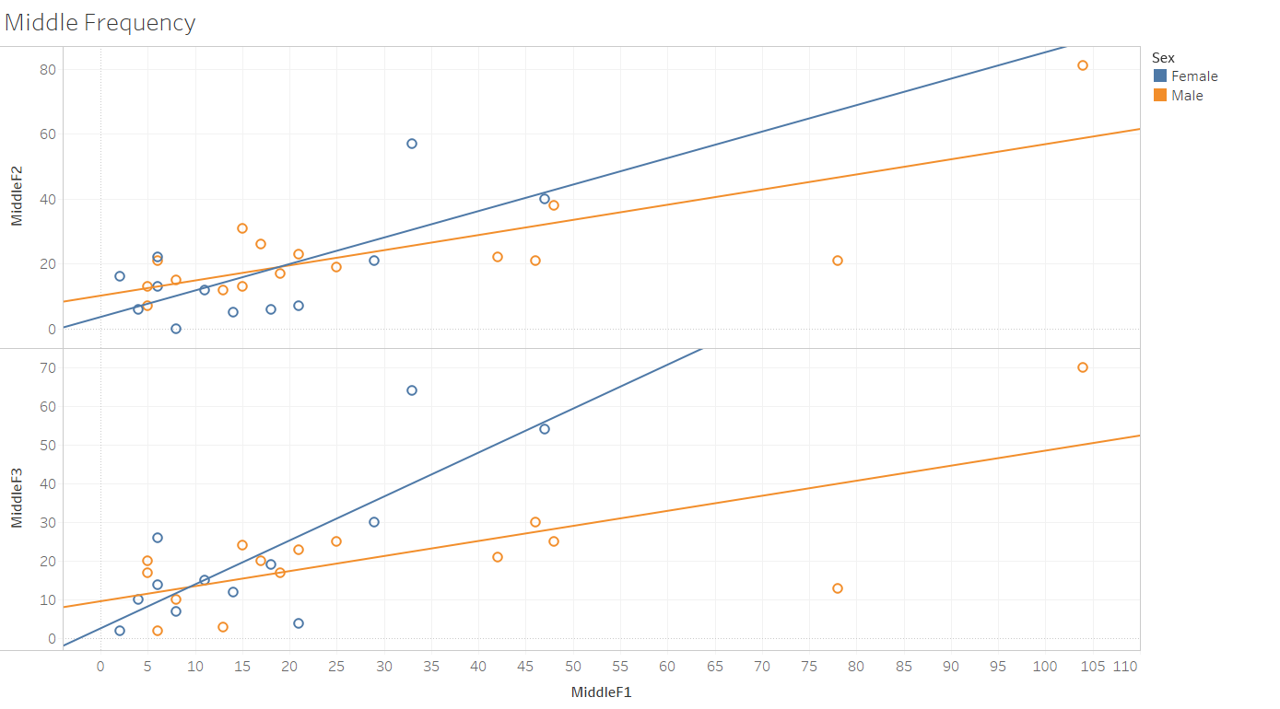

Figure 5: All control, male vs female (Middle Frequency parameter)

**Trend Lines Model**

A linear trend model is computed for MiddleF2 given MiddleF1. The model may be significant at p <= 0.05.

|  |  |
| --- | --- |
| **Model formula:** | Sex*( MiddleF1 + intercept ) |
| **Number of modeled observations:** | 28 |
| **Number of filtered observations:** | 0 |
| **Model degrees of freedom:** | 4 |
| **Residual degrees of freedom (DF):** | 24 |
| **SSE (sum squared error):** | 3366.68 |
| **MSE (mean squared error):** | 140.278 |
| **R-Squared:** | 0.55995 |
| **Standard error:** | 11.8439 |
| **p-value (significance):** | 0.0001637 |

**Analysis of Variance:**

|  |  |  |  |  |  |
| --- | --- | --- | --- | --- | --- |
| **Field** | **DF** | **SSE** | **MSE** | **F** | **p-value** |
| **Sex** | 2 | 215.36672 | 107.683 | 0.767641 | 0.475168 |

A linear trend model is computed for MiddleF3 given MiddleF1. The model may be significant at p <= 0.05. The factor Sex may be significant at p <= 0.05.

|  |  |
| --- | --- |
| **Model formula:** | Sex*( MiddleF1 + intercept ) |
| **Number of modeled observations:** | 27 |
| **Number of filtered observations:** | 1 |
| **Model degrees of freedom:** | 4 |
| **Residual degrees of freedom (DF):** | 23 |
| **SSE (sum squared error):** | 3159.31 |
| **MSE (mean squared error):** | 137.361 |
| **R-Squared:** | 0.584754 |
| **Standard error:** | 11.7201 |
| **p-value (significance):** | 0.0001266 |

**Analysis of Variance:**

|  |  |  |  |  |  |
| --- | --- | --- | --- | --- | --- |
| **Field** | **DF** | **SSE** | **MSE** | **F** | **p-value** |
| **Sex** | 2 | 1271.1033 | 635.552 | 4.62685 | 0.0204741 |

**Individual trend lines:**

|  |  |  |  |  |  |  |  |  |  |
| --- | --- | --- | --- | --- | --- | --- | --- | --- | --- |
| **Panes** | | **Color** | **Line** | | **Coefficients** | | | | |
| **Row** | **Column** | **Sex** | **p-value** | **DF** | **Term** | **Value** | **StdErr** | **t-value** | **p-value** |
| MiddleF2 | MiddleF1 | Male | 0.0004574 | 14 | MiddleF1 | 0.466539 | 0.102631 | 4.54578 | 0.0004574 |
|  | | | | | intercept | 10.1329 | 4.10276 | 2.46977 | 0.0269962 |
| MiddleF2 | MiddleF1 | Female | 0.0149907 | 10 | MiddleF1 | 0.815351 | 0.278092 | 2.93195 | 0.0149907 |
|  | | | | | intercept | 3.56209 | 5.88665 | 0.605114 | 0.558584 |
| MiddleF3 | MiddleF1 | Male | 0.0025106 | 13 | MiddleF1 | 0.388983 | 0.10422 | 3.73232 | 0.0025106 |
|  | | | | | intercept | 9.61198 | 4.28395 | 2.24372 | 0.0429019 |
| MiddleF3 | MiddleF1 | Female | 0.0017785 | 10 | MiddleF1 | 1.1349 | 0.269089 | 4.21755 | 0.0017785 |
|  | | | | | intercept | 2.59632 | 5.69607 | 0.455808 | 0.658266 |

---------------------------------------------------------------------------------------------------------------------------------------------------------------------------------

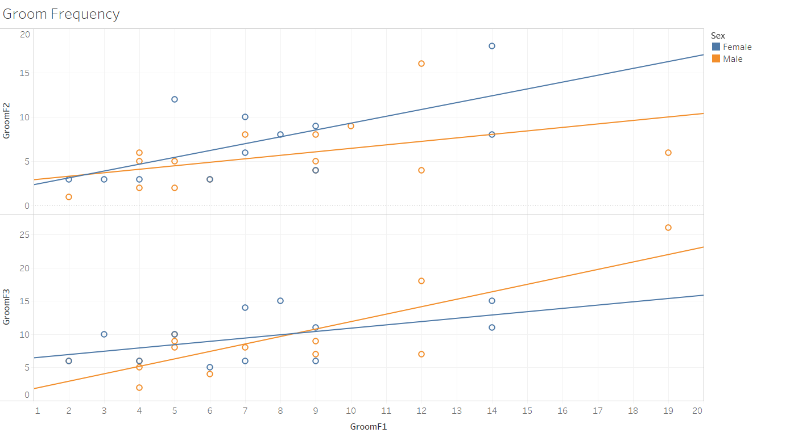

Figure 6: All control, male vs female (Groom Frequency parameter)

**Trend Lines Model**

A linear trend model is computed for GroomF2 given GroomF1. The model may be significant at p <= 0.05.

|  |  |
| --- | --- |
| **Model formula:** | Sex*( GroomF1 + intercept ) |
| **Number of modeled observations:** | 27 |
| **Number of filtered observations:** | 0 |
| **Model degrees of freedom:** | 4 |
| **Residual degrees of freedom (DF):** | 23 |
| **SSE (sum squared error):** | 288.921 |
| **MSE (mean squared error):** | 12.5618 |
| **R-Squared:** | 0.349277 |
| **Standard error:** | 3.54426 |
| **p-value (significance):** | 0.0178508 |

**Analysis of Variance:**

|  |  |  |  |  |  |
| --- | --- | --- | --- | --- | --- |
| **Field** | **DF** | **SSE** | **MSE** | **F** | **p-value** |
| **Sex** | 2 | 38.335312 | 19.1677 | 1.52587 | 0.238642 |

A linear trend model is computed for GroomF3 given GroomF1. The model may be significant at p <= 0.05.

|  |  |
| --- | --- |
| **Model formula:** | Sex*( GroomF1 + intercept ) |
| **Number of modeled observations:** | 26 |
| **Number of filtered observations:** | 1 |
| **Model degrees of freedom:** | 4 |
| **Residual degrees of freedom (DF):** | 22 |
| **SSE (sum squared error):** | 270.947 |
| **MSE (mean squared error):** | 12.3158 |
| **R-Squared:** | 0.580977 |
| **Standard error:** | 3.50938 |
| **p-value (significance):** | 0.0002122 |

**Analysis of Variance:**

|  |  |  |  |  |  |
| --- | --- | --- | --- | --- | --- |
| **Field** | **DF** | **SSE** | **MSE** | **F** | **p-value** |
| **Sex** | 2 | 42.078123 | 21.0391 | 1.7083 | 0.204341 |

**Individual trend lines:**

|  |  |  |  |  |  |  |  |  |  |
| --- | --- | --- | --- | --- | --- | --- | --- | --- | --- |
| **Panes** | | **Color** | **Line** | | **Coefficients** | | | | |
| **Row** | **Column** | **Sex** | **p-value** | **DF** | **Term** | **Value** | **StdErr** | **t-value** | **p-value** |
| GroomF2 | GroomF1 | Male | 0.0815599 | 13 | GroomF1 | 0.393393 | 0.208375 | 1.88791 | 0.0815599 |
|  | | | | | intercept | 2.53153 | 1.84738 | 1.37034 | 0.193782 |
| GroomF2 | GroomF1 | Female | 0.0252403 | 10 | GroomF1 | 0.771784 | 0.293656 | 2.62819 | 0.0252403 |
|  | | | | | intercept | 1.59025 | 2.40666 | 0.660769 | 0.52369 |
| GroomF3 | GroomF1 | Male | 0.0002744 | 12 | GroomF1 | 1.1212 | 0.221066 | 5.07177 | 0.0002744 |
|  | | | | | intercept | 0.679774 | 1.88971 | 0.359723 | 0.725305 |
| GroomF3 | GroomF1 | Female | 0.0940366 | 10 | GroomF1 | 0.495851 | 0.268019 | 1.85006 | 0.0940366 |
|  | | | | | intercept | 5.9471 | 2.19656 | 2.70746 | 0.0220295 |
| ----------------------------------------------------------- | | | | |  |  |  |  |  |

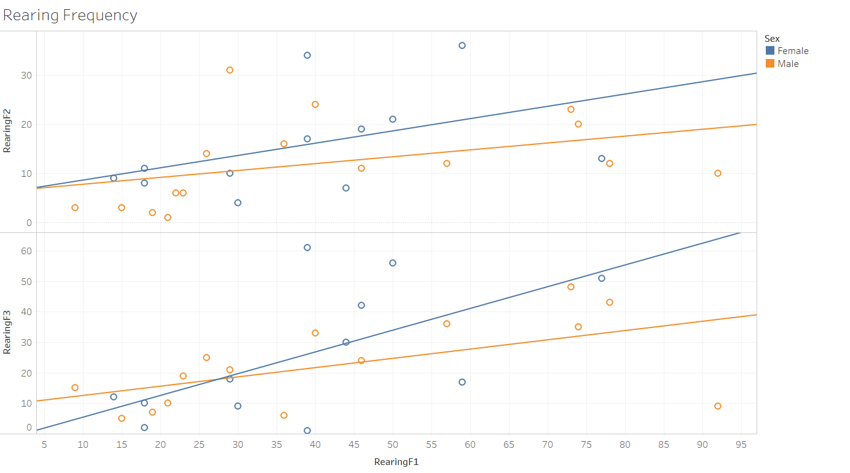

Figure 7: All control, male vs female (Rearing Frequency parameter)

**Trend Lines Model**

A linear trend model is computed for RearingF2 given RearingF1.

|  |  |
| --- | --- |
| **Model formula:** | Sex*( RearingF1 + intercept ) |
| **Number of modeled observations:** | 28 |
| **Number of filtered observations:** | 0 |
| **Model degrees of freedom:** | 4 |
| **Residual degrees of freedom (DF):** | 24 |
| **SSE (sum squared error):** | 1906.76 |
| **MSE (mean squared error):** | 79.4484 |
| **R-Squared:** | 0.214066 |
| **Standard error:** | 8.91338 |
| **p-value (significance):** | 0.116723 |

**Analysis of Variance:**

|  |  |  |  |  |  |
| --- | --- | --- | --- | --- | --- |
| **Field** | **DF** | **SSE** | **MSE** | **F** | **p-value** |
| **Sex** | 2 | 146.63508 | 73.3175 | 0.922832 | 0.411038 |

A linear trend model is computed for RearingF3 given RearingF1. The model may be significant at p <= 0.05.

|  |  |
| --- | --- |
| **Model formula:** | Sex*( RearingF1 + intercept ) |
| **Number of modeled observations:** | 27 |
| **Number of filtered observations:** | 1 |
| **Model degrees of freedom:** | 4 |
| **Residual degrees of freedom (DF):** | 23 |
| **SSE (sum squared error):** | 5084.47 |
| **MSE (mean squared error):** | 221.064 |
| **R-Squared:** | 0.359531 |
| **Standard error:** | 14.8682 |
| **p-value (significance):** | 0.0150463 |

**Analysis of Variance:**

|  |  |  |  |  |  |
| --- | --- | --- | --- | --- | --- |
| **Field** | **DF** | **SSE** | **MSE** | **F** | **p-value** |
| **Sex** | 2 | 613.98225 | 306.991 | 1.3887 | 0.269539 |

**Individual trend lines:**

|  |  |  |  |  |  |  |  |  |  |
| --- | --- | --- | --- | --- | --- | --- | --- | --- | --- |
| **Panes** | | **Color** | **Line** | | **Coefficients** | | | | |
| **Row** | **Column** | **Sex** | **p-value** | **DF** | **Term** | **Value** | **StdErr** | **t-value** | **p-value** |
| RearingF2 | RearingF1 | Male | 0.115211 | 14 | RearingF1 | 0.139872 | 0.0832791 | 1.67956 | 0.115211 |
|  | | | | | intercept | 6.35527 | 4.01838 | 1.58155 | 0.136075 |
| RearingF2 | RearingF1 | Female | 0.145104 | 10 | RearingF1 | 0.25014 | 0.15828 | 1.58037 | 0.145104 |
|  | | | | | intercept | 6.09877 | 6.71352 | 0.908431 | 0.385021 |
| RearingF3 | RearingF1 | Male | 0.0272087 | 13 | RearingF1 | 0.303767 | 0.122104 | 2.48777 | 0.0272087 |
|  | | | | | intercept | 9.47979 | 6.04532 | 1.56812 | 0.140863 |
| RearingF3 | RearingF1 | Female | 0.0358155 | 10 | RearingF1 | 0.712432 | 0.293907 | 2.424 | 0.0358155 |
|  | | | | | intercept | -1.738 | 12.4662 | -0.139417 | 0.891889 |
| ------------------------------------------------------------ | | | | |  |  |  |  |  |

**Excretion Graphs**

Terminology and data orientation:

1. All control (Control Groups): means that the compared groups consist of variables those are never been stressed (+male+cover and paired housing).
2. All Groups: means all groups (paired, single, and all 4 stress groups).
3. All Stress Groups: means single group, and the 3 stress groups (single, -male+cover, +male-cover, and -male-cover). All 3 stress groups variable are from single housing (group).
4. Single group: means the variable is from Single housing regardless of the 4 Stress groups.

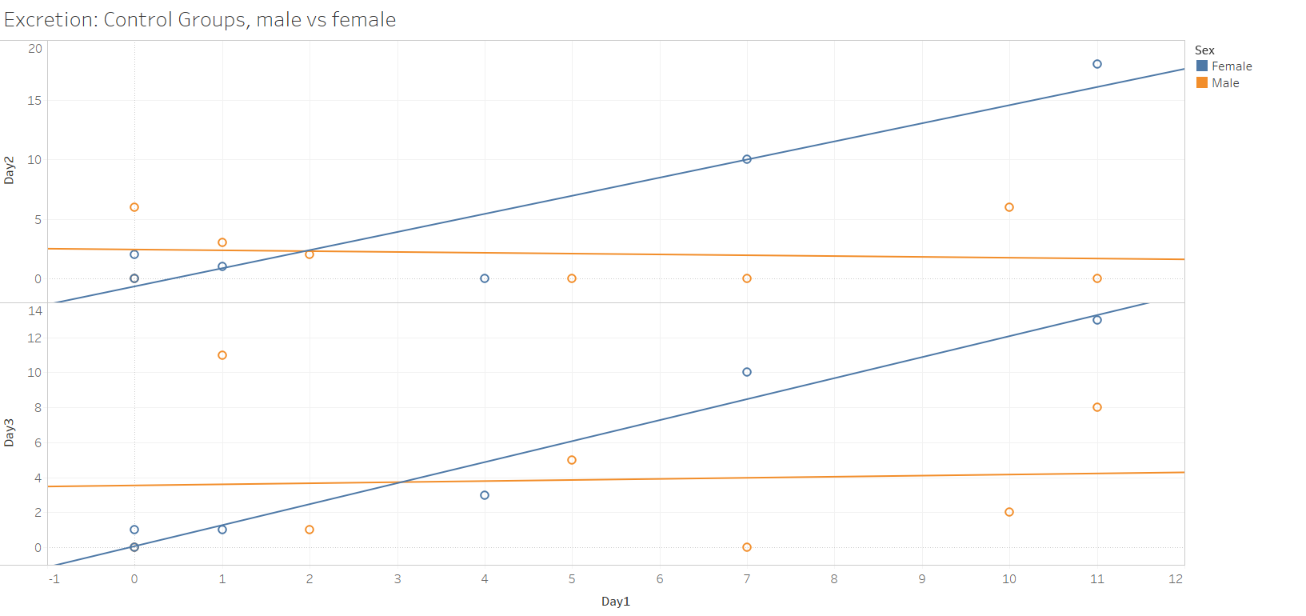

Figure 8: All control, male vs female (Excretion parameter)

**Trend Lines Model**

A linear trend model is computed for Day2 given Day1. The model may be significant at p <= 0.05. The factor Sex may be significant at p <= 0.05.

|  |  |
| --- | --- |
| **Model formula:** | Sex*( Day1 + intercept ) |
| **Number of modeled observations:** | 14 |
| **Number of filtered observations:** | 0 |
| **Model degrees of freedom:** | 4 |
| **Residual degrees of freedom (DF):** | 10 |
| **SSE (sum squared error):** | 88.8922 |
| **MSE (mean squared error):** | 8.88922 |
| **R-Squared:** | 0.745607 |
| **Standard error:** | 2.98148 |
| **p-value (significance):** | 0.0025596 |

**Analysis of Variance:**

|  |  |  |  |  |  |
| --- | --- | --- | --- | --- | --- |
| **Field** | **DF** | **SSE** | **MSE** | **F** | **p-value** |
| **Sex** | 2 | 185.52496 | 92.7625 | 10.4354 | 0.0035667 |

A linear trend model is computed for Day3 given Day1.

|  |  |
| --- | --- |
| **Model formula:** | Sex*( Day1 + intercept ) |
| **Number of modeled observations:** | 13 |
| **Number of filtered observations:** | 0 |
| **Model degrees of freedom:** | 4 |
| **Residual degrees of freedom (DF):** | 9 |
| **SSE (sum squared error):** | 117.266 |
| **MSE (mean squared error):** | 13.0296 |
| **R-Squared:** | 0.552944 |
| **Standard error:** | 3.60965 |
| **p-value (significance):** | 0.0549468 |

**Analysis of Variance:**

|  |  |  |  |  |  |
| --- | --- | --- | --- | --- | --- |
| **Field** | **DF** | **SSE** | **MSE** | **F** | **p-value** |
| **Sex** | 2 | 76.720794 | 38.3604 | 2.9441 | 0.103825 |

**Individual trend lines:**

|  |  |  |  |  |  |  |  |  |  |
| --- | --- | --- | --- | --- | --- | --- | --- | --- | --- |
| **Panes** | | **Color** | **Line** | | **Coefficients** | | | | |
| **Row** | **Column** | **Sex** | **p-value** | **DF** | **Term** | **Value** | **StdErr** | **t-value** | **p-value** |
| Day2 | Day1 | Male | 0.785036 | 6 | Day1 | -0.0688406 | 0.241325 | -0.28526 | 0.785036 |
|  | | | | | intercept | 2.43478 | 1.47781 | 1.64756 | 0.150541 |
| Day2 | Day1 | Female | 0.0090568 | 4 | Day1 | 1.51939 | 0.320746 | 4.73706 | 0.0090568 |
|  | | | | | intercept | -0.657673 | 1.79063 | -0.367285 | 0.732013 |
| Day3 | Day1 | Male | 0.892752 | 5 | Day1 | 0.0621891 | 0.438476 | 0.14183 | 0.892752 |
|  | | | | | intercept | 3.53731 | 2.8705 | 1.2323 | 0.272621 |
| Day3 | Day1 | Female | 0.0008022 | 4 | Day1 | 1.20067 | 0.131664 | 9.11922 | 0.0008022 |
|  | | | | | intercept | 0.0640809 | 0.735043 | 0.0871798 | 0.934718 |

**----------------------------------------------------------------------------------------------------------------------------------------------------------------------**

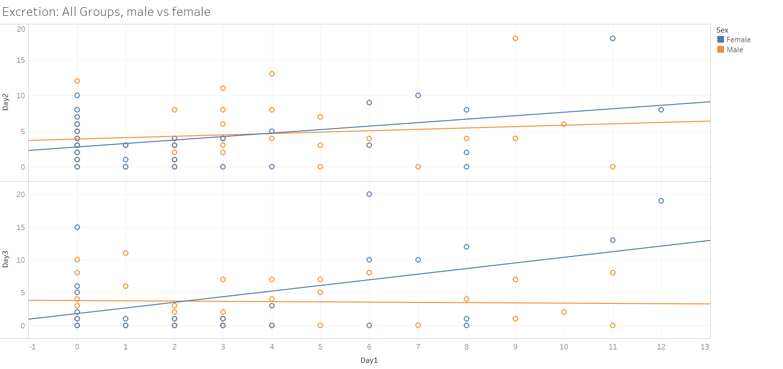

Figure 9: All Groups (paired, single, and all 4 stress groups).

**Trend Lines Model**

A linear trend model is computed for Day2 given Day1.

|  |  |
| --- | --- |
| **Model formula:** | Sex*( Day1 + intercept ) |
| **Number of modeled observations:** | 63 |
| **Number of filtered observations:** | 0 |
| **Model degrees of freedom:** | 4 |
| **Residual degrees of freedom (DF):** | 59 |
| **SSE (sum squared error):** | 970.8 |
| **MSE (mean squared error):** | 16.4542 |
| **R-Squared:** | 0.0923334 |
| **Standard error:** | 4.05638 |
| **p-value (significance):** | 0.1237 |

**Analysis of Variance:**

|  |  |  |  |  |  |
| --- | --- | --- | --- | --- | --- |
| **Field** | **DF** | **SSE** | **MSE** | **F** | **p-value** |
| **Sex** | 2 | 15.044622 | 7.52231 | 0.457166 | 0.635299 |

A linear trend model is computed for Day3 given Day1. The model may be significant at p <= 0.05. The factor Sex may be significant at p <= 0.05.

|  |  |
| --- | --- |
| **Model formula:** | Sex*( Day1 + intercept ) |
| **Number of modeled observations:** | 54 |
| **Number of filtered observations:** | 0 |
| **Model degrees of freedom:** | 4 |
| **Residual degrees of freedom (DF):** | 50 |
| **SSE (sum squared error):** | 1072.67 |
| **MSE (mean squared error):** | 21.4533 |
| **R-Squared:** | 0.195456 |
| **Standard error:** | 4.63177 |
| **p-value (significance):** | 0.0118355 |

**Analysis of Variance:**

|  |  |  |  |  |  |
| --- | --- | --- | --- | --- | --- |
| **Field** | **DF** | **SSE** | **MSE** | **F** | **p-value** |
| **Sex** | 2 | 165.91471 | 82.9574 | 3.86688 | 0.0274477 |

**Individual trend lines:**

|  |  |  |  |  |  |  |  |  |  |
| --- | --- | --- | --- | --- | --- | --- | --- | --- | --- |
| **Panes** | | **Color** | **Line** | | **Coefficients** | | | | |
| **Row** | **Column** | **Sex** | **p-value** | **DF** | **Term** | **Value** | **StdErr** | **t-value** | **p-value** |
| Day2 | Day1 | Male | 0.41089 | 32 | Day1 | 0.19373 | 0.232504 | 0.833233 | 0.41089 |
|  | | | | | intercept | 3.89216 | 1.07808 | 3.61028 | 0.001032 |
| Day2 | Day1 | Female | 0.0238958 | 27 | Day1 | 0.486262 | 0.203146 | 2.39366 | 0.0238958 |
|  | | | | | intercept | 2.78449 | 0.959537 | 2.90191 | 0.0072973 |
| Day3 | Day1 | Male | 0.830331 | 29 | Day1 | -0.0394784 | 0.182586 | -0.216219 | 0.830331 |
|  | | | | | intercept | 3.767 | 0.945336 | 3.98482 | 0.0004169 |
| Day3 | Day1 | Female | 0.0183513 | 21 | Day1 | 0.859477 | 0.336093 | 2.55726 | 0.0183513 |
|  | | | | | intercept | 1.77948 | 1.81939 | 0.978067 | 0.339175 |

**--------------------------------------------------------------------------------------------------------------------------------------------------------------**

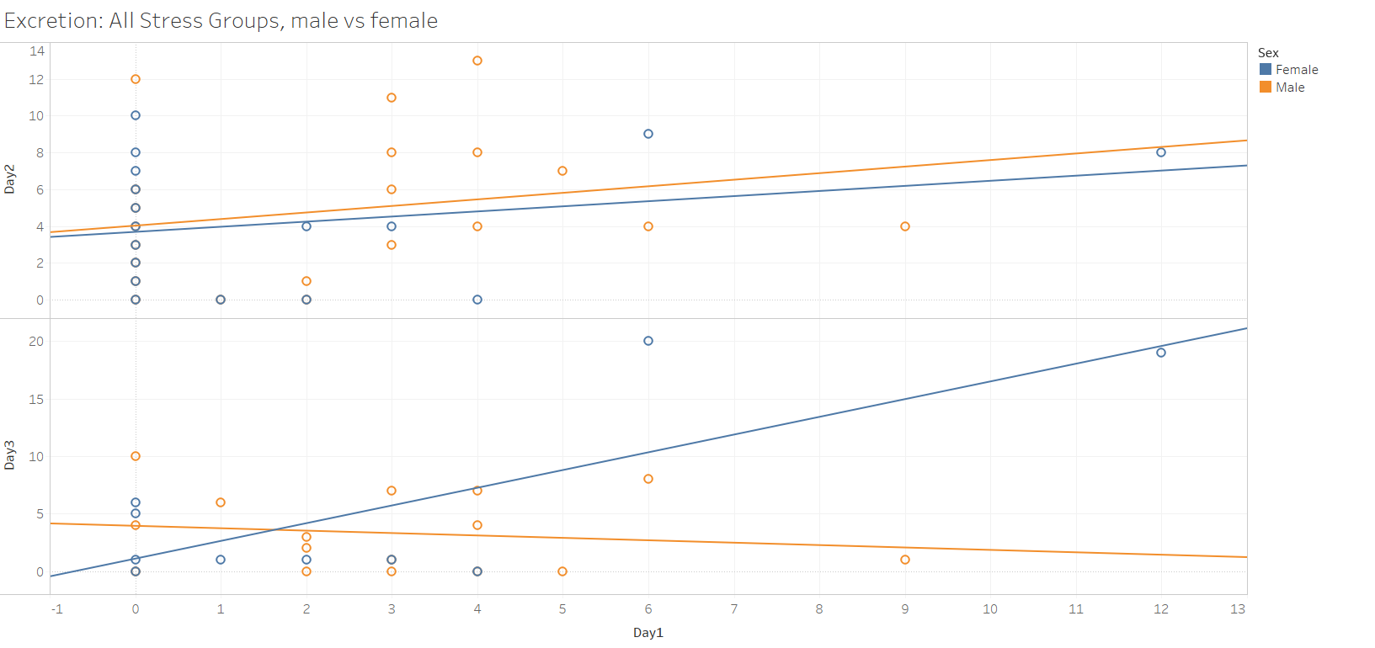

Figure 10: single and one of the following groups ( -male+cover, +male-cover, and -male-cover).

**Trend Lines Model**

A linear trend model is computed for Day2 given Day1.

|  |  |
| --- | --- |
| **Model formula:** | Sex*( Day1 + intercept ) |
| **Number of modeled observations:** | 38 |
| **Number of filtered observations:** | 0 |
| **Model degrees of freedom:** | 4 |
| **Residual degrees of freedom (DF):** | 34 |
| **SSE (sum squared error):** | 457.31 |
| **MSE (mean squared error):** | 13.4503 |
| **R-Squared:** | 0.0655609 |
| **Standard error:** | 3.66746 |
| **p-value (significance):** | 0.505128 |

**Analysis of Variance:**

|  |  |  |  |  |  |
| --- | --- | --- | --- | --- | --- |
| **Field** | **DF** | **SSE** | **MSE** | **F** | **p-value** |
| **Sex** | 2 | 2.7857873 | 1.39289 | 0.103559 | 0.901906 |

A linear trend model is computed for Day3 given Day1. The model may be significant at p <= 0.05. The factor Sex may be significant at p <= 0.05.

|  |  |
| --- | --- |
| **Model formula:** | Sex*( Day1 + intercept ) |
| **Number of modeled observations:** | 26 |
| **Number of filtered observations:** | 0 |
| **Model degrees of freedom:** | 4 |
| **Residual degrees of freedom (DF):** | 22 |
| **SSE (sum squared error):** | 387.548 |
| **MSE (mean squared error):** | 17.6158 |
| **R-Squared:** | 0.469587 |
| **Standard error:** | 4.19712 |
| **p-value (significance):** | 0.0025903 |

**Analysis of Variance:**

|  |  |  |  |  |  |
| --- | --- | --- | --- | --- | --- |
| **Field** | **DF** | **SSE** | **MSE** | **F** | **p-value** |
| **Sex** | 2 | 190.66727 | 95.3336 | 5.41181 | 0.012263 |

**Individual trend lines:**

|  |  |  |  |  |  |  |  |  |  |
| --- | --- | --- | --- | --- | --- | --- | --- | --- | --- |
| **Panes** | | **Color** | **Line** | | **Coefficients** | | | | |
| **Row** | **Column** | **Sex** | **p-value** | **DF** | **Term** | **Value** | **StdErr** | **t-value** | **p-value** |
| Day2 | Day1 | Male | 0.325057 | 19 | Day1 | 0.356354 | 0.352729 | 1.01028 | 0.325057 |
|  | | | | | intercept | 4.02565 | 1.17995 | 3.4117 | 0.002926 |
| Day2 | Day1 | Female | 0.314768 | 15 | Day1 | 0.277575 | 0.266872 | 1.0401 | 0.314768 |
|  | | | | | intercept | 3.68663 | 0.946861 | 3.89353 | 0.0014401 |
| Day3 | Day1 | Male | 0.581517 | 14 | Day1 | -0.209302 | 0.370944 | -0.564242 | 0.581517 |
|  | | | | | intercept | 3.94041 | 1.40641 | 2.80174 | 0.0141317 |
| Day3 | Day1 | Female | 0.0099788 | 8 | Day1 | 1.54103 | 0.459076 | 3.35682 | 0.0099788 |
|  | | | | | intercept | 1.08511 | 2.10375 | 0.515796 | 0.619945 |

**------------------------------------------------------------------------------------------------------------------------------------------------------------------**

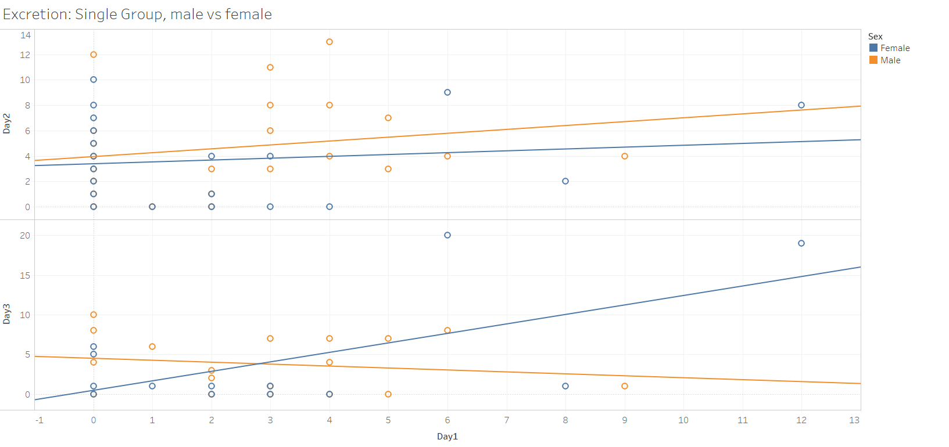

Figure 11: Single housing and one of (+male+cover, -male+cover, +male-cover, -male-cover).

**Trend Lines Model**

A linear trend model is computed for Day2 given Day1.

|  |  |
| --- | --- |
| **Model formula:** | Sex*( Day1 + intercept ) |
| **Number of modeled observations:** | 43 |
| **Number of filtered observations:** | 0 |
| **Model degrees of freedom:** | 4 |
| **Residual degrees of freedom (DF):** | 39 |
| **SSE (sum squared error):** | 502.921 |
| **MSE (mean squared error):** | 12.8954 |
| **R-Squared:** | 0.0505087 |
| **Standard error:** | 3.59102 |
| **p-value (significance):** | 0.562738 |

**Analysis of Variance:**

|  |  |  |  |  |  |
| --- | --- | --- | --- | --- | --- |
| **Field** | **DF** | **SSE** | **MSE** | **F** | **p-value** |
| **Sex** | 2 | 11.350654 | 5.67533 | 0.440104 | 0.647128 |

A linear trend model is computed for Day3 given Day1. The model may be significant at p <= 0.05.

|  |  |
| --- | --- |
| **Model formula:** | Sex*( Day1 + intercept ) |
| **Number of modeled observations:** | 31 |
| **Number of filtered observations:** | 0 |
| **Model degrees of freedom:** | 4 |
| **Residual degrees of freedom (DF):** | 27 |
| **SSE (sum squared error):** | 564.071 |
| **MSE (mean squared error):** | 20.8915 |
| **R-Squared:** | 0.292229 |
| **Standard error:** | 4.57072 |
| **p-value (significance):** | 0.0233593 |

**Analysis of Variance:**

|  |  |  |  |  |  |
| --- | --- | --- | --- | --- | --- |
| **Field** | **DF** | **SSE** | **MSE** | **F** | **p-value** |
| **Sex** | 2 | 126.90853 | 63.4543 | 3.03732 | 0.0645989 |

**Individual trend lines:**

|  |  |  |  |  |  |  |  |  |  |
| --- | --- | --- | --- | --- | --- | --- | --- | --- | --- |
| **Panes** | | **Color** | **Line** | | **Coefficients** | | | | |
| **Row** | **Column** | **Sex** | **p-value** | **DF** | **Term** | **Value** | **StdErr** | **t-value** | **p-value** |
| Day2 | Day1 | Male | 0.366941 | 21 | Day1 | 0.305858 | 0.331691 | 0.922117 | 0.366941 |
|  | | | | | intercept | 3.95095 | 1.12376 | 3.51585 | 0.0020541 |
| Day2 | Day1 | Female | 0.553799 | 18 | Day1 | 0.145555 | 0.241242 | 0.603357 | 0.553799 |
|  | | | | | intercept | 3.38706 | 0.920206 | 3.68076 | 0.0017104 |
| Day3 | Day1 | Male | 0.495683 | 16 | Day1 | -0.244806 | 0.351126 | -0.697203 | 0.495683 |
|  | | | | | intercept | 4.4986 | 1.32159 | 3.40392 | 0.00363 |
| Day3 | Day1 | Female | 0.02502 | 11 | Day1 | 1.19561 | 0.461154 | 2.59264 | 0.02502 |
|  | | | | | intercept | 0.46 | 2.16678 | 0.212296 | 0.835759 |